Manual Test Plan Assignment 1.2

1. Run GameController.java under userInterface folder. It will display the following:

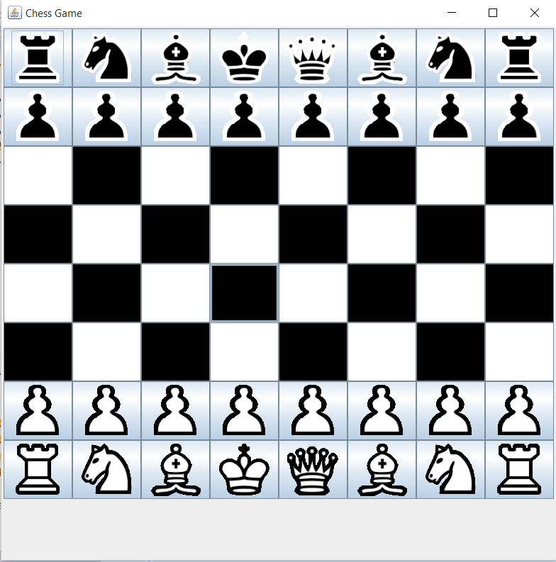

1. White starts first, move a white pawn piece. It will have the following result:

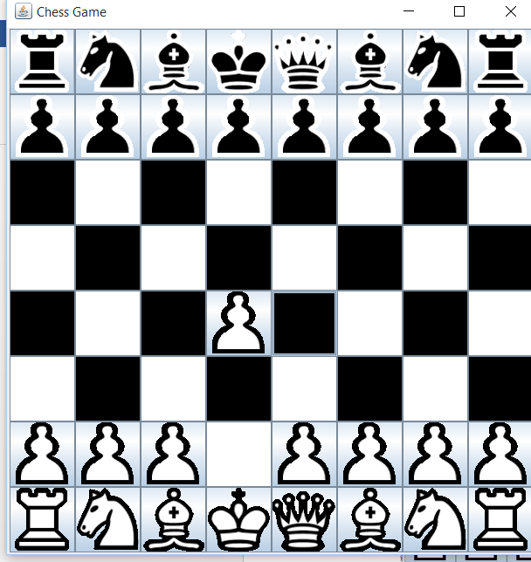

1. Black’s turn. Move a pawn piece. Show invalid message like the following if black tries to move a white piece:

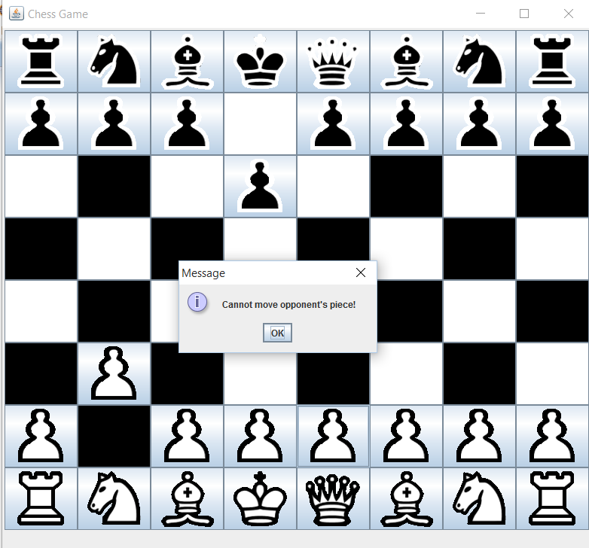

1. Press “u” to undo the move. The board will display the previous move made by the player.



1. Press “f” to forfeit the game. A new board will appear.

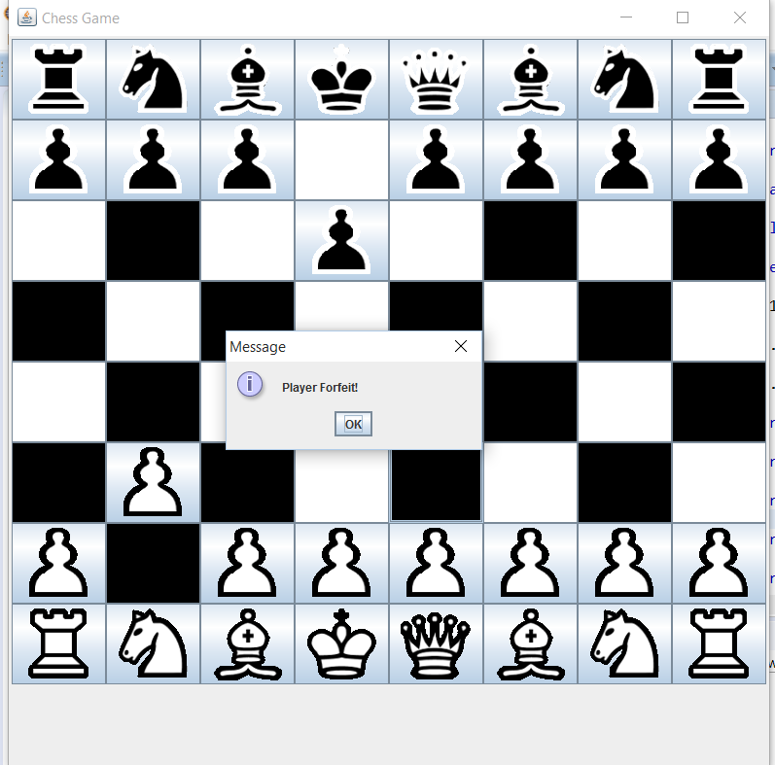

1. Press “r” to restart the game. A new board will appear